***Machine Learning Introduction***

***Introduction :-***

Machine learning is an application of artificial intelligence (AI) that provides systems the ability to automatically learn and improve from experience without being explicitly programmed. What this means Exactly ? The goal is to understand the structure of data and fit that data into models that can be understood and utilized by people. Machine learning is a subfield of artificial intelligence (AI).

***For Example :-*** Think machine is like a Student, How student prepares for the exam? First a student will take the text book and will study every thing and then he will be attend for the exam, same in machine learning we train the machine with some data and then will predict the test data.

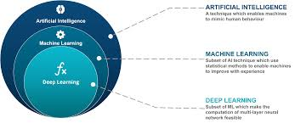

Although machine learning is a field within computer science, it differs from traditional computational approaches. In Normal computer science the algorithm will be coded explicitly to solve the problems. ***For example*** suppose you need to calculate the values then we will write code for the calculator in our favorite language. But in machine learning we will train the data for this and we will pass values into it, machine will answers automaticaly. ***For Example*** here the data was going to be train on the calculations and then will be tested on the unknown data it will give answers without any explicitly coding.

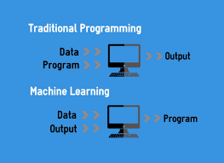

***How Machine Learning Works ?*** *There will be some algorithms Like SVM, KNN etc..* we will fit data into the algorithm and then it will train on that data, then we will test or predict on Unknown data.

There are some Machine Learning Methods

1) Supervised Learning

2) Unsupervised Learning

3) Semi-Supervised Learning

4) Reinforcement Learning

**Supervised Learning :-**

can apply what has been learned in the past to new data using labeled examples to predict future events. Starting from the analysis of a known training dataset, the learning algorithm produces an inferred function to make predictions about the output values. The system is able to provide targets for any new input after sufficient training. The learning algorithm can also compare its output with the correct, intended output and find errors in order to modify the model accordingly.

***For Example :-*** In supervised learning data we will have both the features and labels. In our dataset we are having Features(Age, Has Job, Own House, Credit Rating) and labels(class). This data is about the loan approval. Suppose you have taken loan from the bank they will enquire all the about you like, your property, married status, credit balance. On this info they accept or reject your form. Because loan will be approval on your status that you can pay or not.

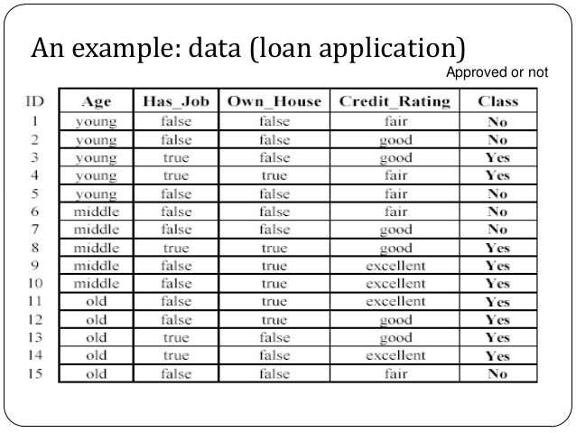

Unsupervised :-

are used when the information used to train is neither classified nor labeled. Unsupervised learning studies how systems can infer a function to describe a hidden structure from unlabeled data. The system doesn’t figure out the right output, but it explores the data and can draw inferences from datasets to describe hidden structures from unlabeled data.

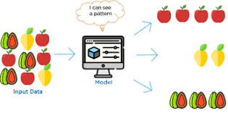

***For example :-*** In UnSupervised learning the data will be divided into the clusters or groups on the basis of there characters. *Suppose we are different types of fruits machine take there feature s and then dive into groups based on there features.* Take features as taste, color, size, etc.. there will be differnent for different fruits machine will learn that features and then if features are same it make that fruit into one group same will reapeat all the fruits.

This is how Unsupervised learning works

**Semi Supervised Learning :-**

supervised and unsupervised learning, since they use both labeled and unlabeled data for training. In semi supervised learning small amount of labeled data and a large amount of unlabeled data. The systems that use this method are able to considerably improve learning accuracy. Usually, semi-supervised learning is chosen when the acquired labeled data requires skilled and relevant resources in order to train it / learn from it. Otherwise, acquiring unlabeled data generally doesn’t require additional resources.

How ***Semi-SuperVised Learning*** works ? First it will train on small amount of data from large amount of data. On this basis of algorithm accuracy user will give unlabeled data then it will increa se the accuracy of the model.

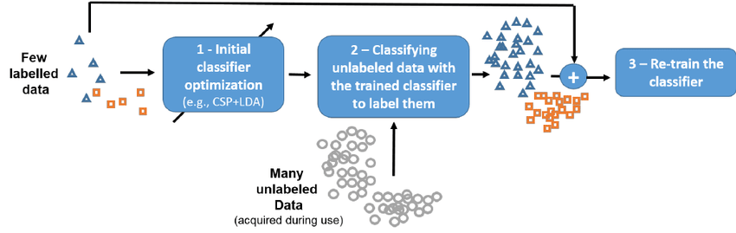

***ReinForcement Learning :-***

interacts with its environment by producing actions and discovers errors or rewards. Trial and error search and delayed reward are the most relevant characteristics of reinforcement learning. This method allows machines and software agents to automatically determine the ideal behavior within a specific context in order to maximize its performance. Simple reward feedback is required for the agent to learn which action is best; this is known as the reinforcement signal.

***For Example :-*** Reinforcement learnes from trail and error. We know how small child learns walking first he will fall and again stands and will try to walk it will be done for servel times. When we are learning bike, cycle, every where we learn from mistakes same will be done in Reinforcement learning

***Data-cleaning :-***

The main aim of Data Cleaning is to identify and remove errors & duplicate data, in order to create a reliable dataset. This improves the quality of the training data for analytics and enables accurate decision-making.